# Advanced Software Testing(ITA6013)

1. [Dashboard](https://lms.vit.ac.in/my/)
2. My courses
3. [ITA6013_W20](https://lms.vit.ac.in/course/view.php?id=929" \o "Advanced Software Testing(ITA6013))
4. [upload Selenium IDE exercise](https://lms.vit.ac.in/mod/assign/view.php?id=21471" \o "Assignment)

## upload Selenium IDE exercise

**20MCA1013 DINESH YOGESH PAREKH 05/03/2021**

I Tested IRCTC web site it properly working or not using Selenium IDE

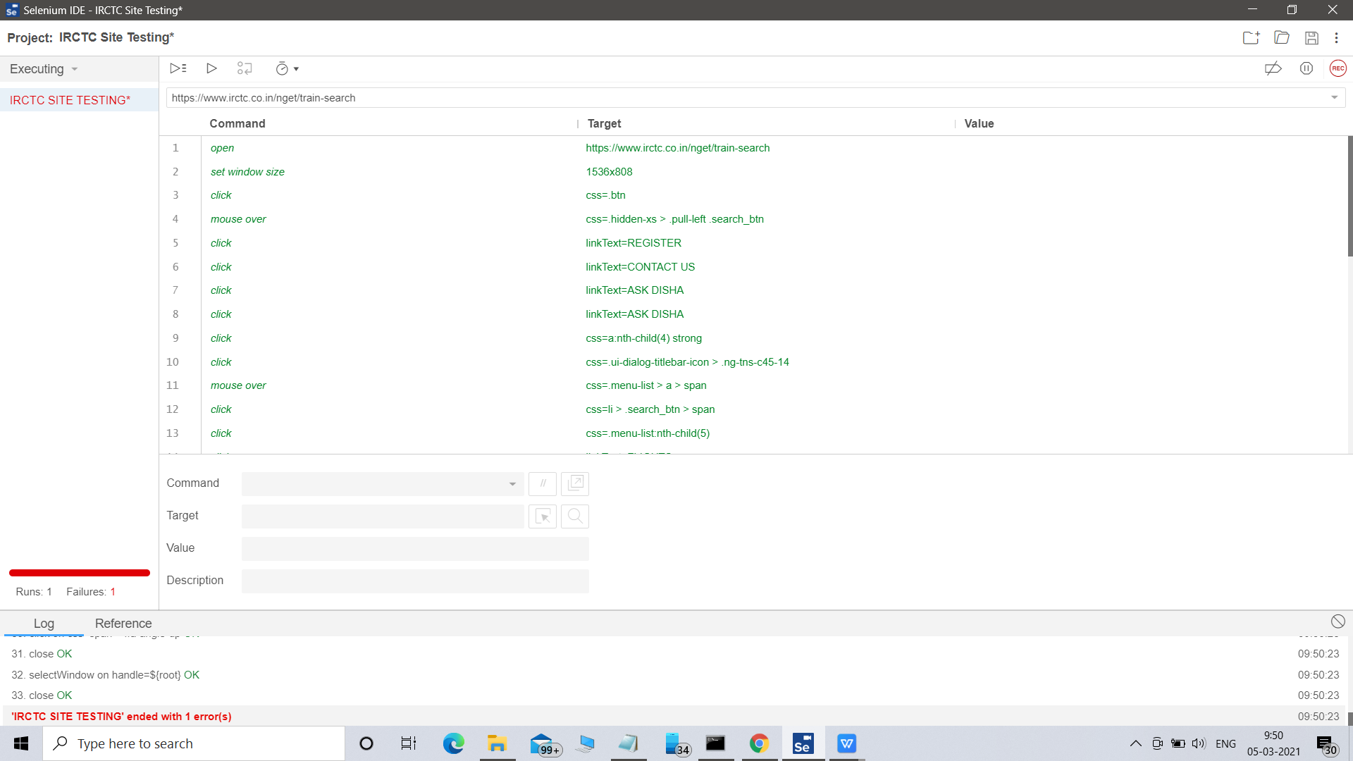

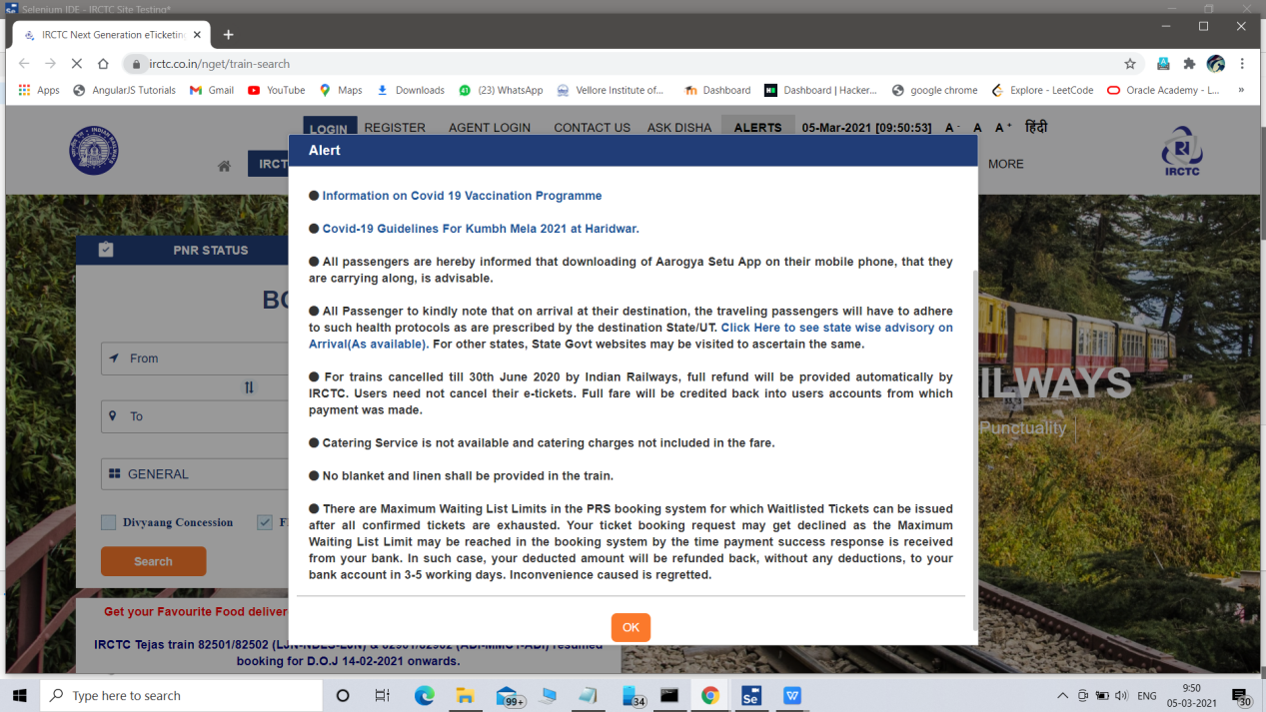

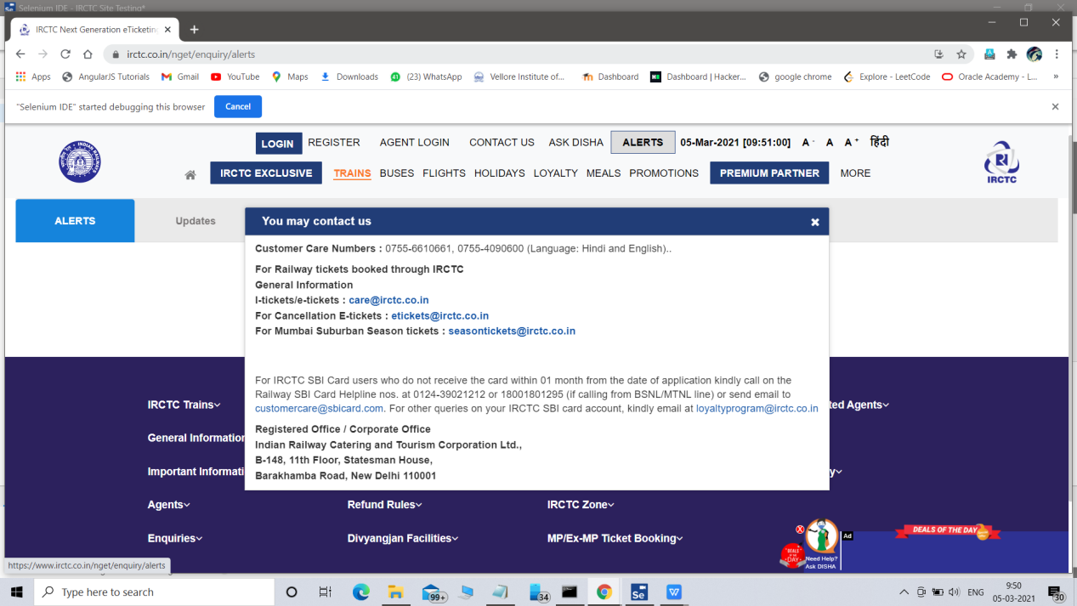

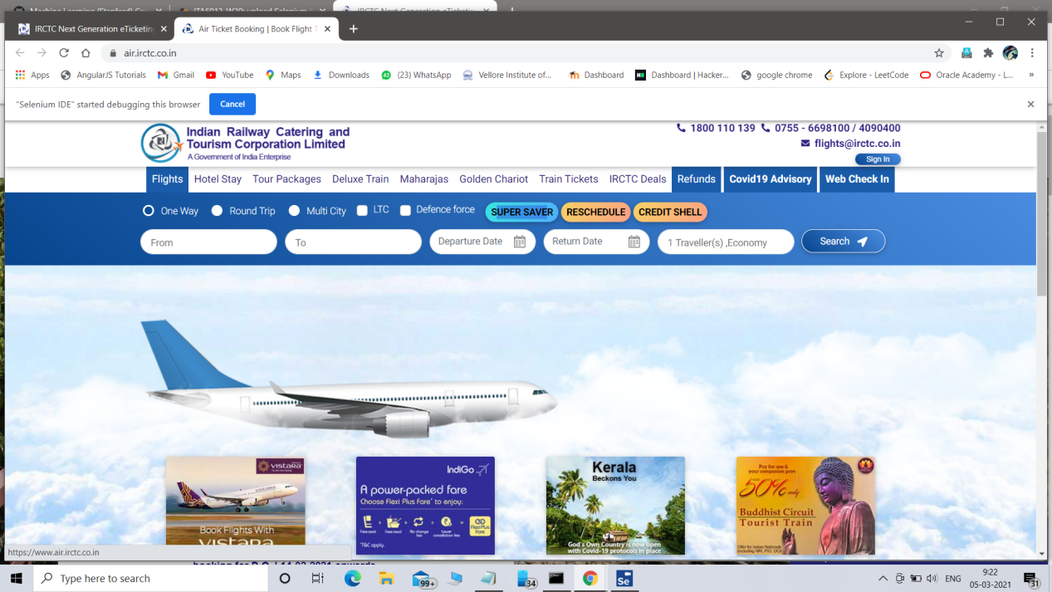

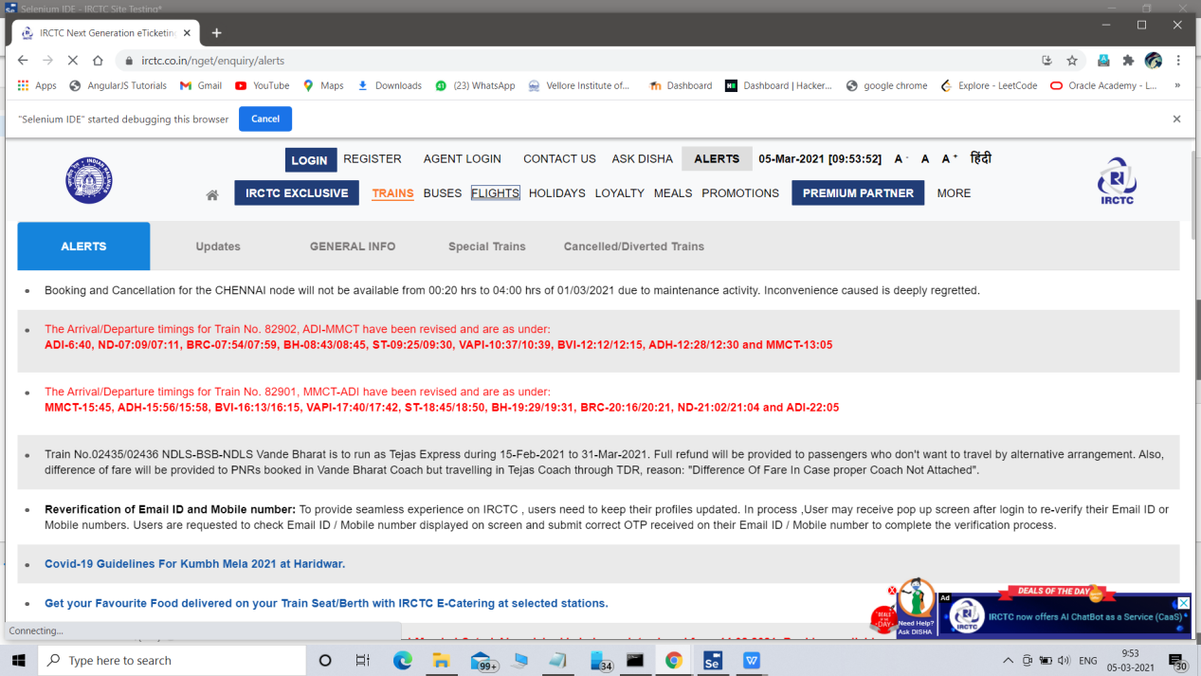

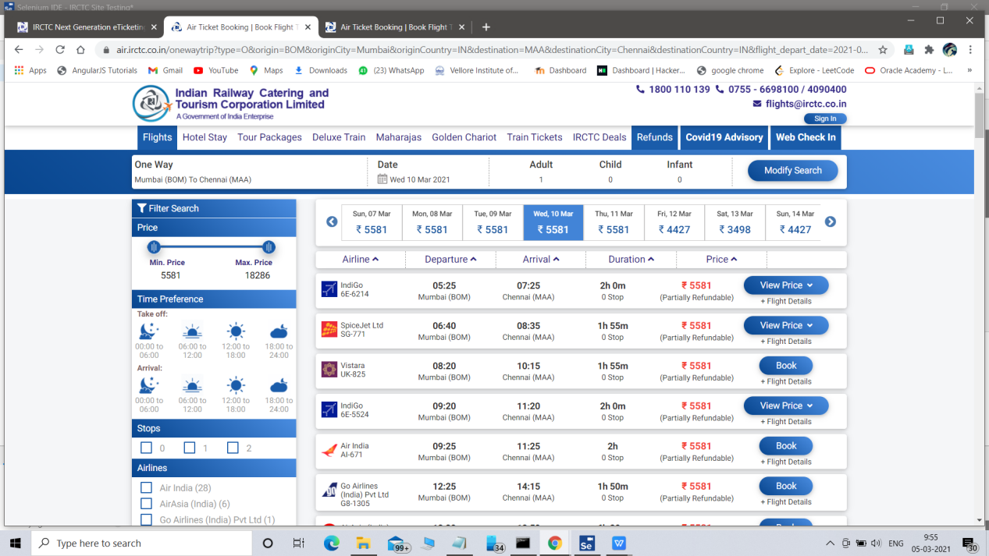

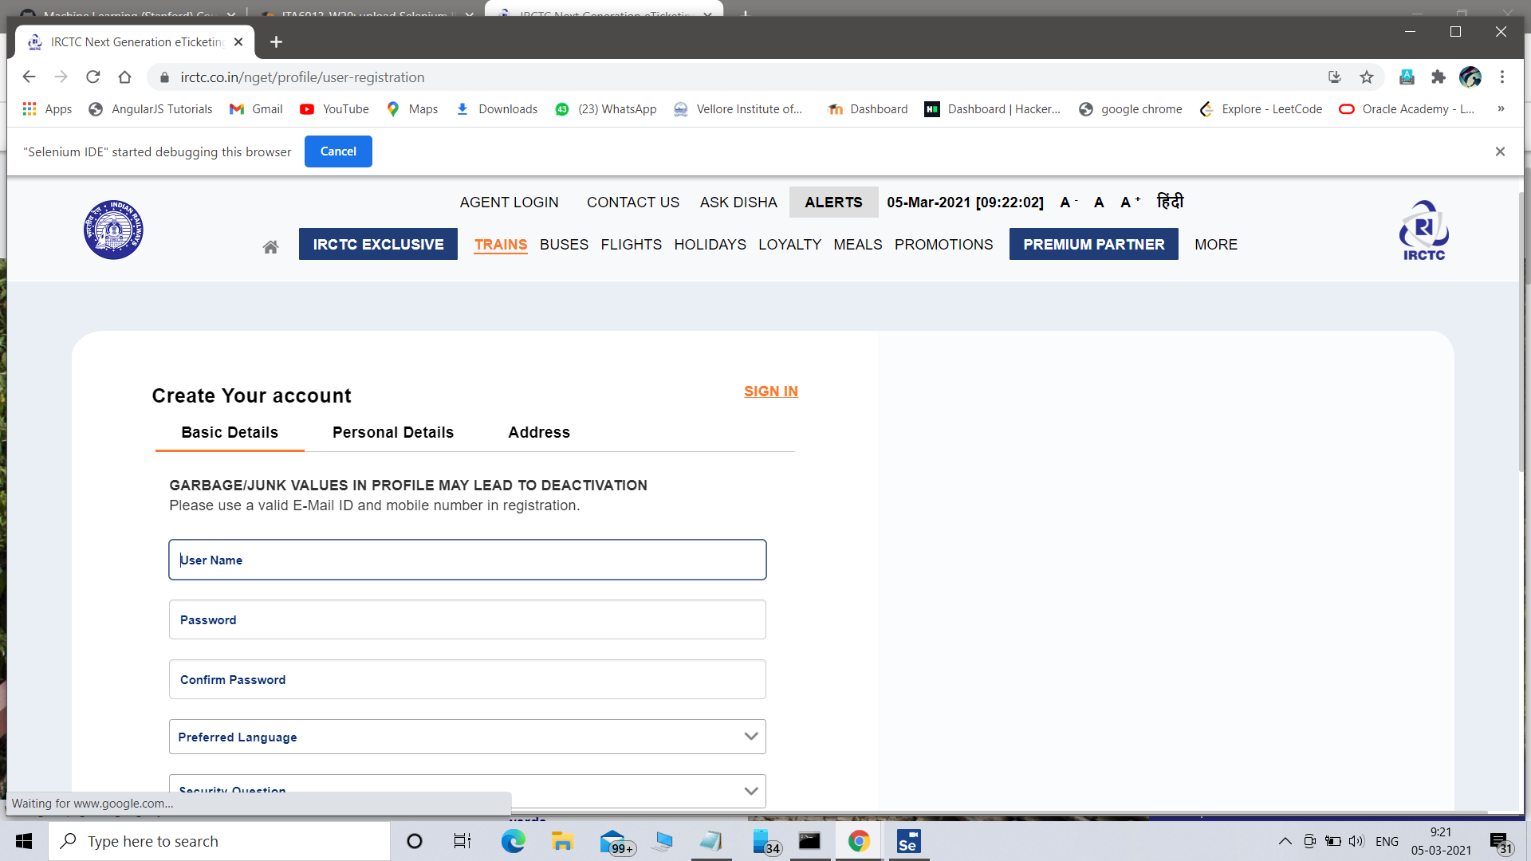

**Commands in Selenium IDE**

* **Assert**. When an "assert" command fails, the test is stopped immediately.
* **Verify**. When a "verify" command fails, Selenium IDE logs this failure and continues with the test execution.

|  |  |
| --- | --- |
| **Command** | **Description** |
| Open | Opens a page using a URL. |
| click/clickAndWait | Clicks on a specified element. |
| type/typeKeys | Types a sequence of characters. |
| verifyTitle/assertTitle | Compares the actual page title with an expected value. |
| verifyTextPresent | Checks if a certain text is found within the page. |
| verifyElementPresent | Checks the presence of a certain element. |

